Creating Accessible Documents

Microsoft Word, Microsoft Excel, Microsoft PowerPoint, and PDFs

Table of Contents

1. Introduction 3

1.1. Macros 3

1.2. Form Fields in Microsoft Word 3

2. Accessibility Standards and Practices 3

2.1. Web Content Accessibility Guidelines (WCAG) 3

2.1.1. The POUR Principles 3

2.1.2. Levels of Conformance 4

2.2. Section 508 4

2.3. Accessible Electronic Document Community of Practice (AED CoP) 5

3. Microsoft Word Documents 5

3.1. File Format 5

3.1.1. Proper File Type 5

3.1.2. Descriptive File Name 5

3.1.3. Restrictive Editing 6

3.2. Content Formatting 6

3.2.1. Headings 6

3.2.2. List Formatting 7

4. Microsoft Excel Documents 8

5. Microsoft PowerPoint Documents 8

6. PDF Documents 8

7. Resources 8

7.1. Government Sites and Documents 9

7.2. Microsoft Sites and Documents 9

7.3. W3C Sites and Documents 9

7.4. Additional Resources 9

8. Glossary 9

9. References 9

10. Change Log 9

1. Introduction

Creating Accessible documents is incredibly important for the progression of society. An inaccessible document locks people out of information through no fault of their own. This can result in poor communication of information, lack of educational/employment opportunities, alienating individuals, and more. By creating accessible documents you help avoid these issues and make the world a more inclusive place for all.

This document will help guide you through some of the best practices regarding creating Accessible documents and some of the factors that influence what is considered accessible. Additional resources that can help you better understand the content presented here can be found in the **Resources** section later in this document.

* 1. Macros

When testing a document containing macros for accessibility, it is important to use a more software application-oriented method of testing. Documents containing macros tend to have a different file extension from those that do not. For example, Microsoft Word documents with macros have a file extension of **docm** or **dotm**.

* 1. Accessibility Checkers in Office Apps

Office apps, both desktop and web based, have an Accessibility Checker built in since the 2016/2019 based versions. These are commonly accessed using the **Review** tab in the menu bar, or by going to “**File** tab > **Info** > **Check for Issues** > **Check Accessibility**.”

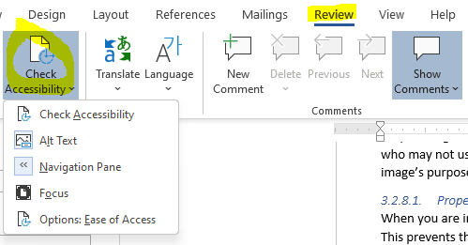

Figure : Check Accessibility under the Review tab in Word

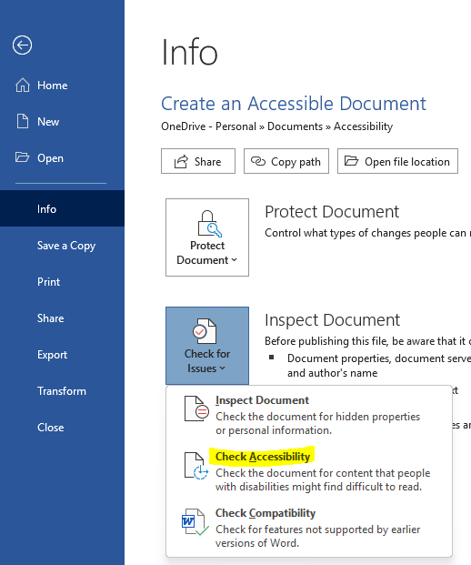

Figure : Info pane under the File tab with the Check Accessibility option highlighted

1. Accessibility Standards and Practices

There are a variety of regulations, standards, and practices revolving around Accessibility. This section will cover some of the most commonly recognized ones relevant to individuals within the United States (US), or working with US companies and/or organizations.

* 1. Web Content Accessibility Guidelines (WCAG)

The **Web Content Accessibility Guidelines** (**WCAG**), were developed by the **Web Accessibility Initiative** (**WAI**) of the **World Wide Web Consortium** (**W3C**) in cooperation with various individuals and organizations worldwide. They were initially published in 1999 and have since undergone multiple revisions. As of July 2021, the current version is 2.1, which was first approved in June 2018. Version 2.2 is scheduled to be finalized by the end of 2021.

The WCAG have become the foundation for most Accessibility regulations, standards, and practices. Section 508, ADA, and more are heavily influenced by the evolution of WCAG. In many cases, meeting the recommended level of conformance with WCAG standards will get you incredibly close to meeting any accessibility regulations you are required to meet for documents, web applications, and software applications.

* + 1. The POUR Principles

As of version 2.1, WCAG focuses on 13 Guidelines divided into 4 primary principles known as the POUR principles, which are **Perceivable**, **Operable**, **Understandable**, and **Robust**. Each of these 4 principles is laid out in the following sub-sections with their applicable guidelines listed. View the [WCAG 2.1 site](https://www.w3.org/TR/WCAG21/) for more information on each principle along with its relevant guidelines and success criterion.

* + - 1. Perceivable

The **Perceivable** principle states that Information and user interface components must be presentable to users in ways they can perceive.

* + - * 1. Relevant Perceivable Guidelines

The main guidelines that apply to the Perceivable principle include:

* **Guideline 1.1:** Text Alternatives: Provide text alternatives for any non-text content so that it can be changed into other forms people need, such as large print, braille, speech, symbols, or simpler language.
* **Guideline 1.2:** Time-based media: Provide alternatives for time-based media.
* **Guideline 1.3:** Adaptable: Create content that can be presented in different ways (for example simpler layout) without losing information or structure.
* **Guideline 1.4:** Distinguishable: Make it easier for users to see and hear content including separating foreground from background.
  + - 1. Operable

The **Operable** principle states that user interface components and navigation must be operable.

* + - * 1. Relevant Operable Guidelines

The main guidelines that apply to the Operable principle include:

* **Guideline 2.1:** Keyboard Accessible: Make all functionality available from a keyboard.
* **Guideline 2.2:** Enough Time: Provide users enough time to read and use content.
* **Guideline 2.3:** Seizure and Physical Reactions: Do not design content in a way that is known to cause seizures.
* **Guideline 2.4:** Navigable: Provide ways to help users navigate, find content, and determine where they are.
* **Guideline 2.5:** Input Modalities: Make it easier for users to operate functionality through various inputs beyond keyboard.
  + - 1. Understandable

The **Understandable** principle states that information and the operation of user interface must be understandable.

* + - * 1. Relevant Understandable Guidelines

The main guidelines that apply to the Understandable principle include:

* **Guideline 3.1:** Readable: Make text content readable and understandable.
* **Guideline 3.2:** Predictable: Make web pages appear and operate in predictable ways.
* **Guideline 3.3:** Input Assistance:Help users avoid and correct mistakes.
  + - 1. Robust

The **Robust** principle states that content must be robust enough that it can be interpreted reliably by a wide variety of user agents, including assistive technologies.

* + - * 1. Relevant Robust Guidelines

The main guidelines that apply to the Robust principle include:

* **Guideline 4.1:** Maximize compatibility with current and future user agents, including assistive technologies.
  + 1. Levels of Conformance

Each guideline is divided up into Success Criteria that better define how to reach one of the 3 levels of conformance to WCAG standards for a particular guideline. These levels are **A**, **AA**, and **AAA**.

Conformance level **A** is considered the lowest level of conformance and level **AAA** is the highest. In general, it is recommended that you aim for at least AA level conformance overall, and AAA where applicable and/or possible.

AAA tends to be more specialized in terms of audience and material presented. It is not possible to meet all success criteria for AAA conformance. You can learn more about WCAG conformance levels by reading the [Conformance](https://www.w3.org/TR/WCAG21/#conformance) section of WCAG 2.1.

* 1. Section 508

In 1986, Section 508 (29 U.S.C. § 794d) was added as an amendment to the Rehabilitation Act of 1973. The amendment was added to help remove barriers to information that can prevent access by individuals with disabilities. It applies to the way in which Federal agencies develop, procure, maintain, and use **Information and Communication technologies** (**ICT**).

Section 508 requires US Federal agencies and federal contractors receiving funds from the US government to make their electronic and information technology accessible to their employees and members of the public with disabilities that is comparable to the access granted to others.

* 1. Accessible Electronic Document Community of Practice (AED CoP)

The **Accessible Electronic Document Community of Practice** (**AED CoP**), which is a part of the Federal CIO Council, was created by a group of Federal Subject Matter Experts (SMEs) with the goals of:

* Improving accessible content posted on Federal agency websites
* Advancing the field of accessibility
* Creating reusable accessibility information and artifacts

They created various guides containing steps that can be used to make an electronic document Section 508 compliant.

1. Microsoft Word Documents

This section will detail ways to ensure your Microsoft Word documents are Accessible. Some of these are probably things you are doing already, but others may be things you never would have considered as needed to make the document accessible. Some things are required before you ever start adding content to the file.

* 1. Reveal Formatting pane

Often you will see the **Reveal Formatting** pane listed as the method for testing whether something is formatted properly. Anytime you need to open this pane, simply:

1. Select the text you wish to inspect the formatting of or place your cursor within it.
2. Press the **Shift** key and the **F1** key together on your keyboard.

Doing so will open the **Reveal Formatting** pane.

* 1. File Format

Items in this section deal with how you set up the file itself before adding in content.

* + 1. Proper File Type

Make sure to save the file with the newer **docx** extension and not the older **doc** extension. This helps to ensure better compatibility with newer **Assistive Technology** (**AT**).

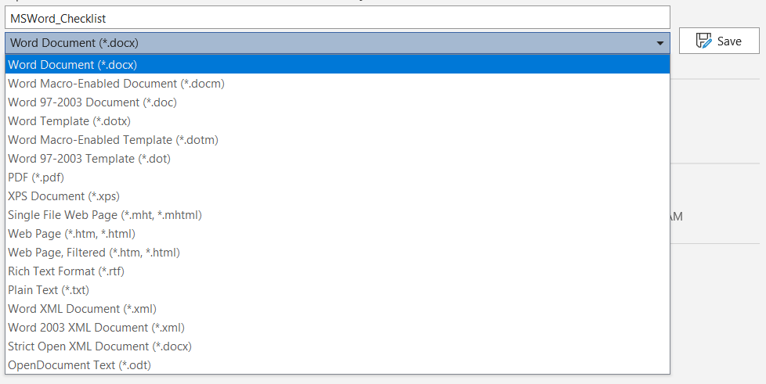

Figure : Microsoft Word file save dialogue.

* + 1. Descriptive File Name

Ensure the file name helps to differentiate the file from other Microsoft Word files and gives the user an idea of what the document contains.

|  |  |
| --- | --- |
| Non-descript Filename Example | Descriptive Filename Example |
| Untitled.docx | MSWord_Checklist.docx |

Table : Filename examples

This is also a great example of how something done for Accessibility benefits everyone. Just think of how much easier it is to locate a specific document when the names help to differentiate them and hint at their purpose versus. For instance, look at the 2 example file lists in the next table.

|  |  |
| --- | --- |
| Group of Non-descript Filenames Example | Group of Descriptive Filenames Example |
| Untitled.docx  Untitled(1).docx  GDoc-18762.docx | MSWord_Checklist.docx  Payroll-Policies-2021.docx  WCAG-22-Draft.docx |

Table : Example using groups of filenames

When the file names are descriptive, finding a specific file is far quicker even under stressful circumstances.

* + 1. Restrictive Editing

Document restrictions limit or prevent users of AT from reading or editing the document in part because they interfere with how AT interact with the file content. If you must use document restrictions, ensure assistive technology users have access to the password necessary to turn them off.

* 1. Content Formatting

Now we get into how you format the content in your document to make it accessible to your end users.

* + 1. Headings

If a text item is meant to be a heading, it is not enough for it to visually look like a heading. It needs to use a proper heading style in Word.

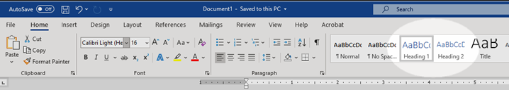

Figure : Heading Styles in Microsoft Word

* + - 1. Testing Headings

To pass this, all headings must show up appropriately in the **Navigation pane** of Word. This is particularly important since Assistive technology can not infer meaning purely based on how you chose to manually format the text.

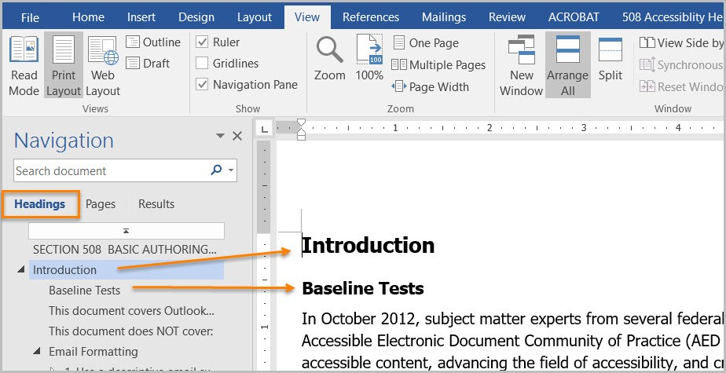

Figure : Microsoft Word Navigation Pane.

Properly formatted headings that show up properly in the Navigation pane also serve to make the content more easily navigated in general regardless of whether AT is being used.

* + - 1. Custom Headings

If you need a custom heading look that is not offered by Microsoft Word, you can create a custom one. However, make sure to set the settings correctly so that the heading is recognized as the proper heading level by Word.

To do so, make sure to set the “**Style based on**” option to the appropriate heading level when you are modifying your new heading style. Also make sure to select “**Linked (paragraph and character)**” from the “**Style type**” drop-down if it is not already selected. Finally, set the “**Style for following paragraph**” to “**Normal**” to ensure that it automatically switches to the normal paragraph font when you go down the next line after a header.

It is also important that a custom heading have a descriptive name that helps identify what its purpose is. This will help anyone else using your custom heading later and will help you if you need to go back and use it in the future.

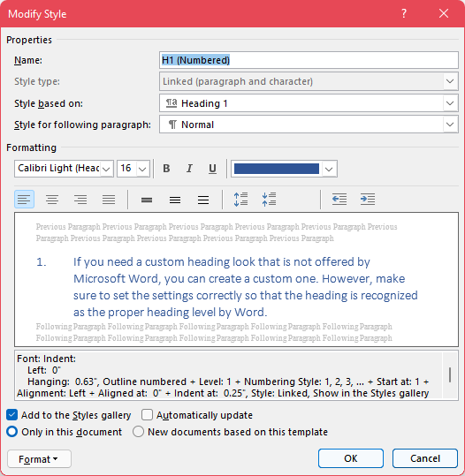

Figure : Modify style dialogue window

* + 1. List Formatting

Lists being properly formatted in a document ensures that AT can properly infer order and meaning. This means making sure to use list styles built into Microsoft Word. Word does give you the option to make custom list styles, similar to how you can make custom heading styles.

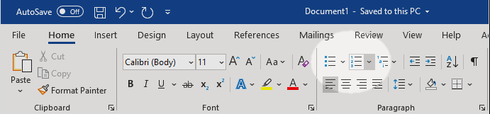

Figure : List style buttons in Microsoft Word

* + - 1. Testing Lists

You can check if a list is properly counted as a list using the **Reveal Formatting pane**. If it is properly formatted, you will see the list information displayed in the pane.

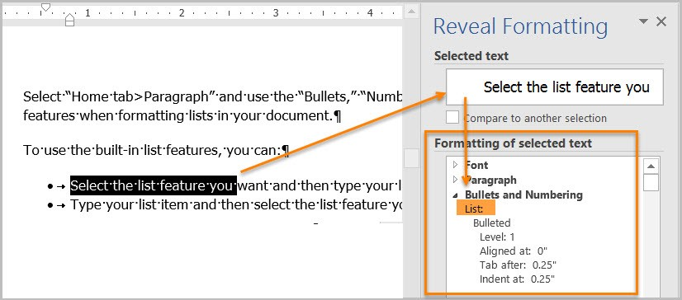

Figure : Microsoft Word Reveal Formatting pane

* + - 1. Ordered versus Unordered

**Ordered lists** are used to indicate that the order of the items in the list is significant. They are typically used for lists of steps that need to be completed in a particular order. These lists are typically formatted with list markers like Roman numerals, Arabic numerals, or other alphanumeric characters where order has meaning.

Ordered list formatting should not be used for **Unordered lists**. Items in unordered lists don’t necessarily need to be listed in a particular order, though you may still choose to list them in some form of logical order (**e.g.** listing ingredients based on what part of the dish they are used in and the order in which those parts are made in the instructions). Unordered lists could include lists of ingredients in a recipe, hardware in a box, etc.

* + 1. Column Formatting

When you wish to organize content in a Word document into columns, it is important to use the built in **Column** options to do so. Attempting to give content the look of being in columns using tables, tabbing, or spaces will cause AT to not read the content correctly.

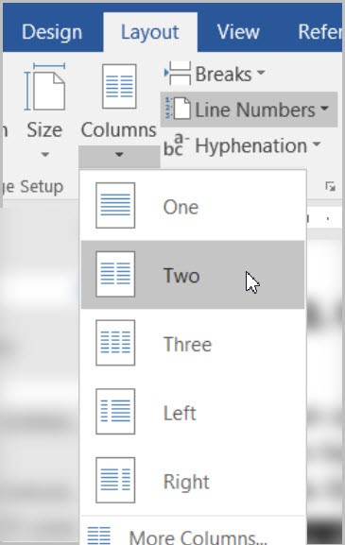

Figure : Column options in Word under Layout Tab

* + - 1. Testing Column Formatting

You can use the **Reveal Formatting** pane to test whether columns are properly formatted and recognized by Word as columns. Your content fails if you place your cursor within content that visually appears to be in a column format, but the Reveal Formatting pane does not list them as being in columns.

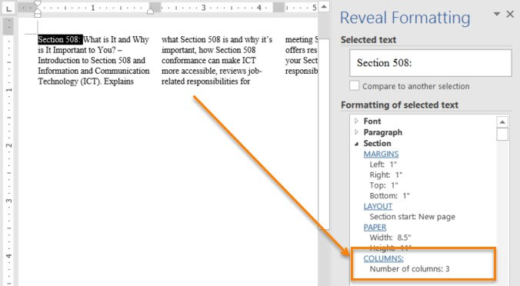

Figure : Reveal Formatting pane recognizing columns

* + 1. Table Formatting

Properly formatting tables in Microsoft Word ensures that information will be properly recognized by AT. You should make sure to use the built-in table inserting option, and not just visually create a table using spacing, tabs, or indentions. If content is merely formatted to visually look like a table without being inside a table, AT will not be able to properly infer that it is a table.

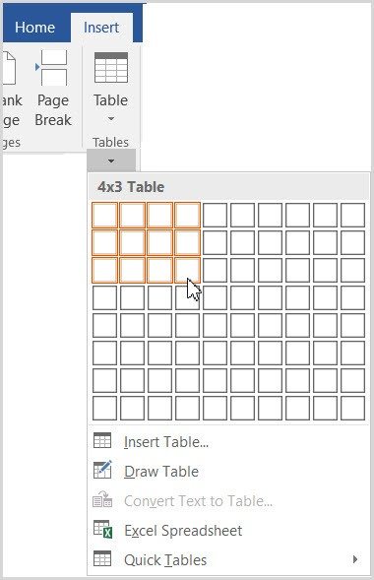

Figure : Table option found under the Insert tab in Word

After selecting the **Table** option under the **Insert** tab in Word, you can either manually select the number of columns and rows using the boxes displayed or select the **Insert Table** option to be taken to a dialogue box where you can type in the number of rows and columns you wish your table to have.

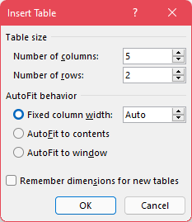

Figure : Insert Table window

* + - 1. Text Wrapping and Tables

You should turn off Text Wrapping around tables in Microsoft Word. Allowing text to wrap around a table can cause AT to not properly read the table and the surrounding content.

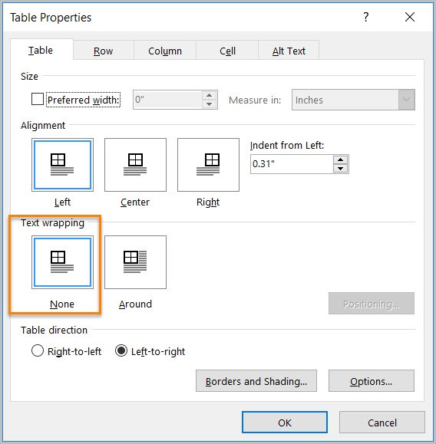

Figure : Table Properties window with text wrapping set to None

* + - 1. Testing Table Formatting

The easiest way to test your table is whether you used the built-in table tool in Word to create it. If so, then you are okay. Your table fails if you instead used tabs, spacing, and indentions to create the visual look of a table.

Can you tab through your table? Does it tab through in a way that matches the visual layout of the content? Many AT users will use a keyboard to navigate content. Therefore, it is important to properly format a table in Word so that it can be properly tabbed through. If your table can be tabbed through, and the tab order matches the visual appearance of the table, your content passes.

* + 1. Language Formatting

If your document is all in one language, then you don’t necessarily need worry about this. However, you can ensure Word recognizes the document as being in all one language by:

1. Highlighting all content in the document.
2. Navigate to the **Review** tab.
3. Click the **Language** button under the **Language** section.
4. Select the **Set proofing language** option.

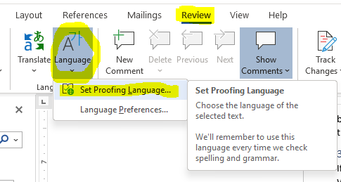

Figure : Language options in Word with Set Proofing Language selected.

1. Select the document’s primary language from the list, and click **OK**.

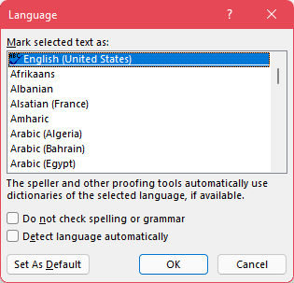

Figure : Proofing language selection menu.

This will ensure that Word recognizes the selected content as the correct language. This is important since it can impact how a screen reader, or other AT, pronounce a particular word when they read it off. Not properly setting the language for a section of text could cause it to be mispronounced, which can alter the meaning of some words.

* + - 1. Setting a different language

If you have an individual word or block of text that is in a language other than the predominant one for the document, you can use the same methods shown about to set the language for just that section of text.

Simply highlight the section of text that is in a different language, and then navigate to the **Set Proofing Language** option, but select the language of that section instead of the predominant one for the document.

* + - 1. Testing Language Formatting

To test language formatting, refer to the **Reveal Formatting pane** used in previous sections. This time, make sure to place your cursor within the section of text that you know if a language other than the predominant one for the document. The Reveal Formatting pane will display what language it has interpreted the text as being. If a language other than the one of the text is displayed, then you need to highlight the text and change its proofing language.

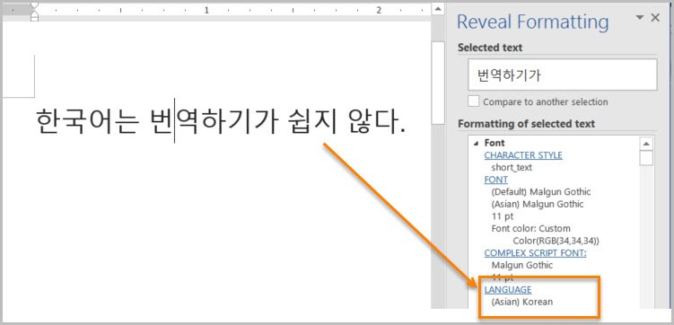

Figure : Reveal Formatting pane identifying language of text

* + 1. Link Formatting

Most AT will recognize links as being links if they are interactive links. If they are simply text, then it will read them off as text. However, there are other things you need to be aware of when creating links; if your intent is to make them the best they can be.

* + - 1. Descriptive Link Text

The link text needs to be descriptive of what the link navigates too. Do not simply label them as “Click Here” and often it is good to avoid spelling out the full URL unless the document is to be printed, or the link is relatively short and clear in meaning. The table below shows 3 examples:

|  |  |  |
| --- | --- | --- |
| Uniquely Named Link | Link Determinable within context | An unclear link name with no context |
| [www.section508.gov](http://www.section508.gov) | [Get My Section 508 Questions Answered](https://section508.gov/content/help-and-faq) | [click here](https://www.opm.gov/) |

Table : Link formatting examples

A lengthy URL may seem to not be problematic, but they can be cumbersome to users regardless of whether they are using AT. This is particularly the case when the links are included in with other text. Below is an example using the URL for a job posting as an example:

|  |  |
| --- | --- |
| Full URL | Descriptive Link Text |
| https://recruiting2.ultipro.com/SOR1001SORE/JobBoard/1fe5e40e-4e0c-4b11-86e3-9a8e1f396263//OpportunityDetail?opportunityId=0102542c-4a92-46ca-b366-cbf35fced749&utm_source=LINKEDIN&utm_medium=referrer | [Software Test Engineer | Sorenson Communications, LLC Opportunities (ultipro.com)](https://recruiting2.ultipro.com/SOR1001SORE/JobBoard/1fe5e40e-4e0c-4b11-86e3-9a8e1f396263/OpportunityDetail?opportunityId=0102542c-4a92-46ca-b366-cbf35fced749&utm_source=LINKEDIN&utm_medium=referrer) |

Table : Full URL versus Descriptive Link Text

Which of the above examples would be more pleasing to see in a paragraph?

Which link has a meaning that is easier to identify?

Which would you prefer having read off to you? This is particularly important since most AT will state that a link is a link if it is an interactive link. AT will then proceed to read the displayed text for the link. As a result, if you just have the URL written out, the AT user will have to listen to a lengthy URL rambled off to them that may not give them any additional useful information about the link’s purpose.

* + - 1. Microsoft Edge and Links

If you copy a link from Microsoft’s Chromium-based Edge browser into Microsoft Word, you may notice that it will automatically format the link text with the page’s title. This can be helpful for pasting a link into a document with already accessible, descriptive link text. However, you may want to edit it down some depending on how the web page designer formatted their page titles. For example, in the previous job posting example, you may want to edit it down so it reads better in the context of other text as shown below:

|  |  |
| --- | --- |
| Original Pasted Link Text | Edited Link Text |
| [Software Test Engineer | Sorenson Communications, LLC Opportunities (ultipro.com)](https://recruiting2.ultipro.com/SOR1001SORE/JobBoard/1fe5e40e-4e0c-4b11-86e3-9a8e1f396263/OpportunityDetail?opportunityId=0102542c-4a92-46ca-b366-cbf35fced749&utm_source=LINKEDIN&utm_medium=referrer) | [Software Test Engineer job posting with Sorenson Communications](https://recruiting2.ultipro.com/SOR1001SORE/JobBoard/1fe5e40e-4e0c-4b11-86e3-9a8e1f396263/OpportunityDetail?opportunityId=0102542c-4a92-46ca-b366-cbf35fced749&utm_source=LINKEDIN&utm_medium=referrer) |

Table : Descriptive Link Text Examples

* + 1. Object Formatting

This section will cover how we need to format things like headers, footers, watermarks, images, and data tables in a document.

* + - 1. Headers, Footers, and Watermarks Formatting

AT does not automatically recognize and read content found in headers, foots, and watermarks. Thus this content should ideally be duplicated near the beginning of the document if it is vital to properly understanding and distributing the document’s content.

For example, if you have a watermark stating that the document is confidential or a draft. This is information that can impact the user’s understanding of the content, and whether they share the content with others. Thus, it should be duplicated within the body of the document, preferably near the top of it.

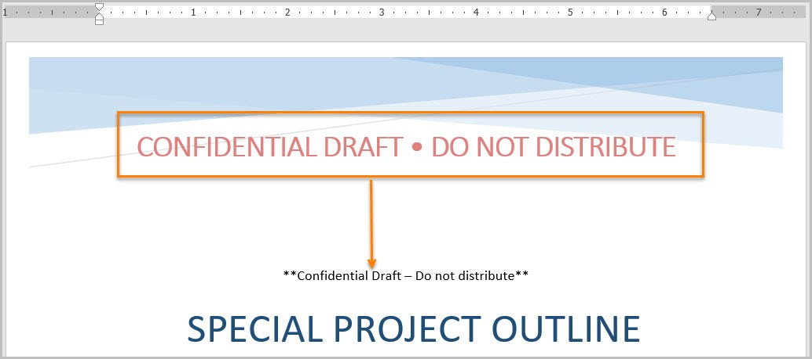

Figure : Example of a watermark displayed in the body of the document

* + - 1. Data Table Formatting

Data tables can be problematic for AT if not properly formatting. The relationship between the individual data items can be lost. Generally, data tables are best saved for web applications where WAI-ARIA can be used to better define the relationship between different cells. They also work out better in Excel spreadsheets.

* + - * 1. Avoid Split or Merged Cells

AT cannot properly identify the relationship between data in split and merged cells. As a result, it is best to avoid them at all costs in Word documents. This is a just because you can do it doesn’t mean you should circumstance.

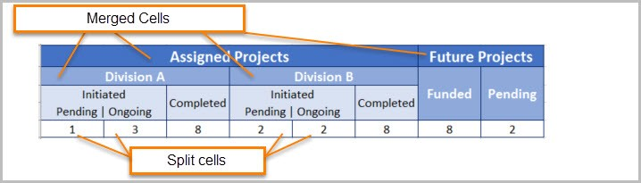

Figure : Complex table with merged and split cells

* + - * 1. Don’t use pictures of tables

If you select a table and the “Picture Tools”, or “Picture Format”, tab shows up, your table fails because it is an image and not a table. AT will not be able to read the text in the picture, or at least will not be able to read it well enough to identify it as a table and convey the relationship between the various cells of the table.

* + - * 1. Ensure the Header Row Repeats

Have you ever seen a table that went across multiple pages, but you had to keep scrolling up to the first page the table was on because the headers were only on that first page? Word has an option to repeat a header row across the top of each page the table is on so the user can easily see the column headers to remember what each is for.

**DO NOT** simply manually recreate the header row on each page. This can lead to confusion because the AT will not recognize the manually created header row as such unless the table on the next page is an entirely separate table from the portion of the table on the previous page.

You can check if a row is properly recognized as a header row and set to repeat by placing your cursor in a cell of the header row, opening the Reveal Formatting pane, and seeing it shows the row set to “Repeat as header row”.

To set this:

1. Place your cursor in one of the cells of the header row and right-click.
2. Select **Table Properties** from the context menu that displays.
3. Under the **Row** table in the **Table Properties**, you will see a check box labeled “Repeat as header row at the top of each page.”

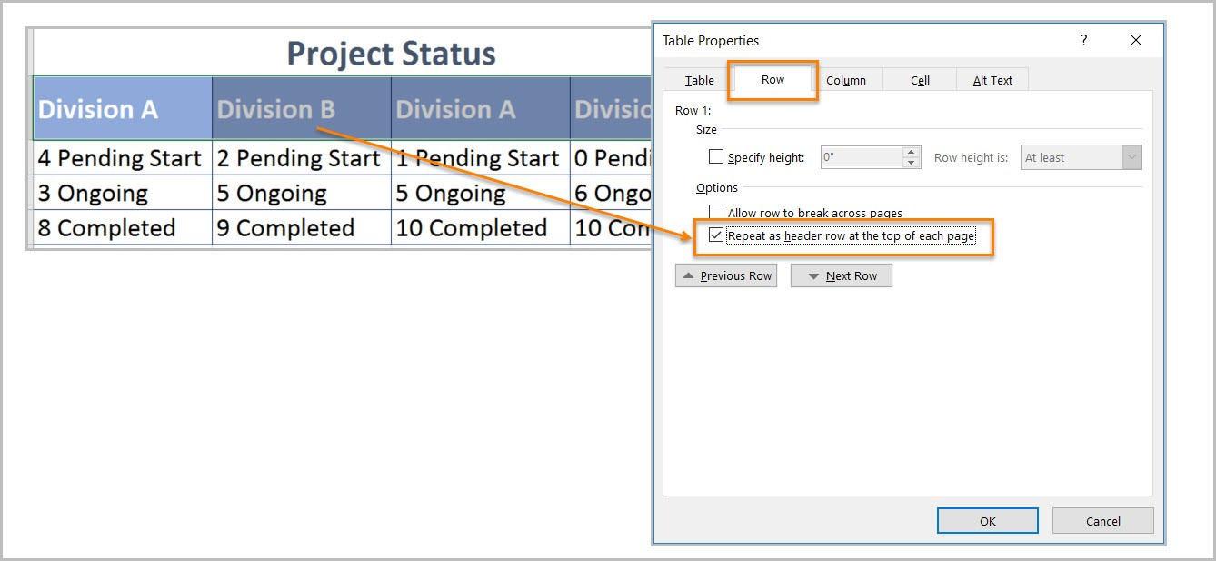

Figure : Table Properties with "Repeat as header row at the top of each page" checked.

It is advised to just turn this on for every table. That way you are covered if it does end up going across multiple pages.

* + - * 1. Text wrapping and tables repeated

This was already covered in section 3.2.4.2, and it is the same here. Turn off text wrapping around tables. It will do nothing but cause chaos for AT and can just look messy in general.

* + - 1. Alternative (Alt) Text

It is important that all images, and other objects like smart shapes, have clear descriptive text if they convey meaning in the document.

Adding Alt Text is super easy. Simply right-click an image, or other object, and select the **Edit Alt Text** option from the context menu that displays. An **Alt Text** pane will display where you can type in a brief description of the image.

In most cases, it is best to limit it to 1-2 sentences unless more detail is needed. The pane will give additional recommendations for things to consider when typing alt text.

It is okay to be more limited, or not include alt text if a description is given in the form of a caption or text around the image. However, it can still be useful to include a very brief identifying alt text description to help better associate the image with the other sources that go into more detail on it.

Make sure to include any text present in the object, and include alt text for logos since they are always considered informative. Make sure that the alt text is descriptive and accurately represents what is conveyed by the object.

* + - 1. Decorative Images/Objects

If an image is decorative, for example a background image, stylized borders, or one that just adds color to the document. These are things that do not convey any information to the reader. Open the **Alt Text** pane as described in the previous section, but make sure to check the box labeled “Mark as decorative.”

* + - 1. Color Formatting

Color formatting is important to ensure visual elements are clearly visible and their information is more clearly conveyed. This means making sure that information is not purely conveyed using color or shapes. Doing so will not give comparable access to individuals who are blind, colorblind, or have low vision. You risk an inconsistent conveying of information because the colors or shapes could be interpreted differently by different people based on how they are able to view it. It is important to use additional methods to convey meaning if color or shape would be the sole method otherwise.

Please note that the table below lists the color names under the example labeled “List using only colors” to ensure someone using AT knows what is being shown while still being able to have the effect of no relevant information about the list being conveyed.

|  |  |
| --- | --- |
| Project Status List using only colors | Project Status List using colors and text |
| * Project A – [Color Green] * Project B – [Color Yellow] * Project C – [Color Red] | * **Project A** **– On-Time** * **Project B** **– At Risk** * **Project C** **– Late** |

Table : Table showing the difference between only using color versus using text with color to convey meaning

* + - 1. Color Contrast

Improper contrast can make reading content difficult for everyone, particularly those who are colorblind or have low vision. If your content is effectively black on a white background, or close to it, you probably have nothing to worry about. However, it is a good idea to test to be sure. The [Color Contrast Analyzer tool](https://www.tpgi.com/color-contrast-checker/) is great for this, and is the tool recommended by the DHS OAST for their Trusted Testers. It is available for Windows and Mac.

Once you have the tool downloaded and installed, you can launch it. From there you can manually enter color Hexes, select them from a menu, or use the dropper tool to select the section whose color you wish to use in your comparison. From there the tool will tell you if the colors contrast enough to pass AA and/or AAA WCAG compliance.

Please note that some color combinations may only pass if they are large text, and not if they are standard size text. You can see more details in the table below:

|  |  |
| --- | --- |
| Type or Size of Text | Contrast Ratio |
| Standard Text (12 pt regular) | 4.5:1 |
| Large Test (14 pt bold or 18 pt regular) | 3:1 |

Table : Table detailing font sizes and expected contrast ratios

It is important to note that incidental text, text overlaid on images, and logotypes are excluded from this requirement.

|  |  |
| --- | --- |
| Good Color Contrast | Insufficient Color Contrast |
| White text on black background  Approximate ratio 21:0:1 | Dark gray text on a black background  Approximate ratio 3:1 |
| Dark green text on yellow background  Approximate ratio 7.6:1 | Orange text on a yellow background  Approximate ratio 2.1:1 |
| Light blue text on dark blue background  Approximate ratio 10.5:1 | Red text on a dark blue background  Approximate ratio 1.1:1 |
| White text on a red background  Approximate ratio 6.5:1 | Dark green text on a red background  Approximate ratio 1.3:1 |

Table : Examples of good and insufficient contrast for comparison

* + - 1. Inline with Text

It is important that tables, images, and other objects be inline with text and not have text wrapped around them. Text wrapping around objects can cause AT to not properly read the content, or to read it in an unintended order that leads to confusion.

You can use the **Accessibility Checker** to identify objects that are not inline with text.

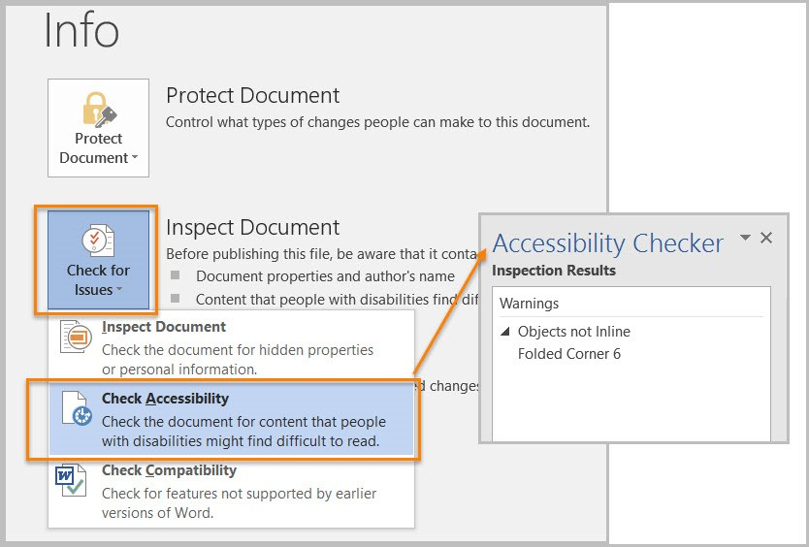

Figure : Accessibility Checker report displaying items not properly inline with text.

To fix items not inline with text, you can:

1. Right-click the object.
2. Select the **Size and Position** option from the context menu.

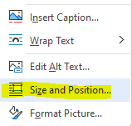

Figure : Object right-click menu with "Size and Position" option

1. Navigate to the **Text Wrapping** tab of the resultant **Layout** window that displays.

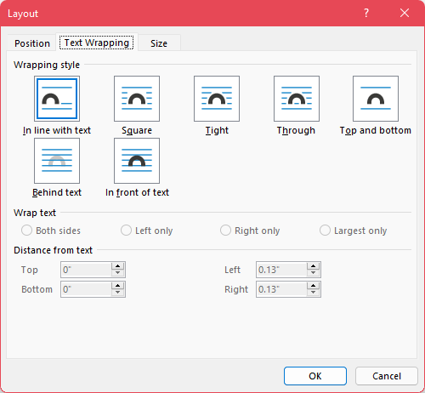

Figure : The "Text Wrapping" tab of the "Layout" window.

1. Select the “In line with text” option and click **OK**.
   * + - 1. Properly Inserting Images

When you are inserting a picture file, using the **Insert** tab in Word will allow you to properly insert them inline with text. This prevents the image from floating about and being in some way wrapped by the text that can interfere with AT reading the content in the proper order.

When pasting an image into a Word document, one thing that can help make sure the image gets properly recognized as an image and is formatted in a way that makes it more accessible, do not simply use ctrl+V to paste the image in. Instead, use the right-click context menu to paste the image in so you can select the “Picture” icon under the “Paste Options.”

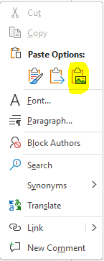

Figure : Right-click Context Menu in Word with Picture paste option highlighted.

Improper insertion, or pasting can lead to it not being inline, which will get picked up by Word’s Accessibility Checker.

* + - 1. Embedded File Descriptions

Information in this section applies if you have embedded audio, video, or multimedia files. Ensure there is the following for each of these media types:

* **Audio Only**
  + Accurate and complete transcript
* **Video Only**
  + Accurate and complete text description
* **Synchronized Media (Audio and Video)**
  + Accurate and complete synchronized captions and audio descriptions
    - 1. Avoid Flashing Objects

Flashing objects are not considered accessible in Word documents since you cannot properly control how frequently they flash or have controls to stop them from playing. As a result, they can pose a lot of difficulties for individuals with certain seizure conditions. So it is recommended to avoid using them at all.

* + - 1. Avoid using any forms

You cannot create a Microsoft Word document with form fields that is considered Section 508 compliant. It is better to create forms in a web/software application or PDF where additional tools are available to properly associate fields and labels, and ensure proper navigation.

1. Microsoft Excel Documents

This section will contain information on what you can do to make your spreadsheets made in Microsoft Excel more accessible to anyone who may need to view them.

* 1. Problematic for Accessibility Testing

The following sub-sections include things that can cause an Excel document to automatically be inaccessible, or at least unable to be fully tested for Accessibility compliance. As a result, these things should be avoided as much as possible. Alternatives will be provided where possible.

* + 1. Excel Spreadsheets with Macros

Technically these files can be tested for Accessibility. However, similar to Word documents, due to the way in which Macros impact the functionality of a document, particularly for AT users, you have to use a more software baseline approach to testing them versus being able to test them with some of the regular built-in features of Excel.

* + 1. Excel Spreadsheets with Forms enabled

Like Word documents, explained in section 3.3.7.10, Forms make Spreadsheet automatically make a Spreadsheet inaccessible. This is because AT cannot properly infer the relationships between certain elements in the context of a Spreadsheet the way they can in an HTML document, PDF, or software application-based form. It is preferred that you use one of those methods to create a form if you truly need one rather than creating one within a Spreadsheet.

* + 1. Restricted Documents

Like Word documents, explained in section 3.2.3, documents that have had restrictions turned on cannot be properly tested for Accessibility because those restrictions can interfere with AT reading the document.

To remove restrictions, go to “File” tab, “Info”, then “Protect Worksheet.” Select “Restricted Permission by People” and check “Unrestricted Access.” Ensure that end users using AT have access to any passwords necessary to turn off these restrictions.

* 1. File Formatting

Items in this section deal with how you format the file before adding any content.

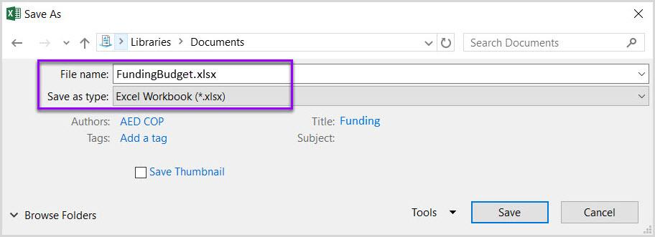

Figure : Excel file with .xlsx file extension and descriptive name

* + 1. Save as a .xlsx Format

It is best to save Excel spreadsheets using the newer .xlsx file extension, and not the older .xls extension, or one of the multiple other extensions available within Excel like .csv or .xml. This ensures better compatibility with AT and easier Accessibility testing.

* + 1. Use a Descriptive File Name

As with any document, ensure that the file name is unique and descriptive so that you, and any users accessing the documents, can easily find a particular document and have a general idea of its purpose.

* 1. Content Formatting
     1. Organize Content and Ensure Logical Reading Order

Logical reading order in an Excel spreadsheet is considered left to right and top to bottom with the starting point being cell A1.

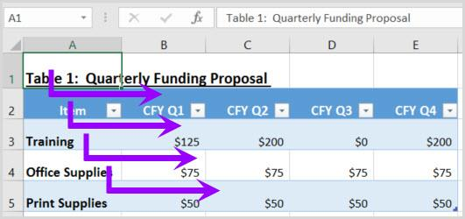

Figure : Spreadsheet with content that follows the logical/visual reading order.

To ensure users can follow the flow of information in your spreadsheet, consider the following:

* **If the spreadsheet is part of a workbook,** make sure each spreadsheet tab has a descriptive and unique name. The name of the tab should provide a clue to what information is being covered in the spreadsheet.
* **Use the Cell Style tool to apply Heading levels,** otherwise known as section levels, such as Title and Heading Level 1 through Heading Level 9. To modify the appearance of the Heading Level, right mouse click on the Heading Level and select Modify.
* **If the content in the spreadsheet needs to be in a data table format,** use the Format as Table tool. Identify a table template that best meets your needs and then modify the template by right mouse clicking on the template and select Modify.
* **Lastly, if data cells require special formatting**, use the Format tool to format the cell.
  + Check out the AED CoP testing guides and checklists listed in the **Resources** section of this document.

Additionally, you want to make sure that content doesn’t span over multiple rows or columns, start content in cell A1 every time, and that it can be navigated using the up, down, left, and right arrow keys in a way that matches the visual/logical reading order.

* + 1. Ensure Contrast Ratio

Contrast Ratios need to be the same as described in section **3.3.7.6** of this document using the [**Color Contrast Analyzer** tool](https://www.tpgi.com/color-contrast-checker/) to ensure contrast meets at least AA compliance.

* + 1. Text Descriptions for Visual Characteristics Used to Convey Meaning

[Placeholder Text]

* + 1. Ensuring Vital Background Information is Accessible

[Placeholder Text]

* + 1. Data Tables

[Placeholder Text]

* + 1. Alt Text for Objects

[Placeholder Text]

* + 1. Descriptive Link Text

[Placeholder Text]

* + 1. Accurate Descriptions for Embedded Media

[Placeholder Text]

* + 1. Avoiding Flashing Objects

[Placeholder Text]

1. Microsoft PowerPoint Documents

[Placeholder Text]

1. PDF Documents

[Placeholder Text]

1. Resources

This section will list out a variety of resources that information was pulled from and/or may provide additional context while you learn about the topics covered in this document.

* 1. Government Sites and Documents

Links and information in this section come from a variety of government sources.

* [Section 508 Official site](https://www.section508.gov/)
  + [Create Accessible Digital Products | Section508.gov](https://www.section508.gov/create)
  + [Test for Accessibility | Section508.gov](https://www.section508.gov/test)
* [U.S. Access Board](https://www.access-board.gov/)
* [US General Services Administration (GSA)](https://www.gsa.gov/)
  1. Microsoft Sites and Documents

Links and information in this section come from a variety of Microsoft sources.

* [Accessibility Technology & Tools | Microsoft Accessibility](https://www.microsoft.com/en-us/accessibility)
* [Accessibility fundamentals - Learn | Microsoft Docs](https://docs.microsoft.com/en-us/learn/paths/accessibility-fundamentals/)
  1. W3C Sites and Documents

Links and information in this section come from a variety of W3C sources.

* [Web Content Accessibility Guidelines (WCAG) Overview | Web Accessibility Initiative (WAI) | W3C](https://www.w3.org/WAI/standards-guidelines/wcag/)
  1. AED CoP Links

These links refer to various pages and downloadable documents relating to AED CoP.

* [Microsoft Word Files and Tips](https://www.section508.gov/create/documents)
* [Microsoft Excel Files and Tips](https://www.section508.gov/create/spreadsheets)
* [Microsoft PowerPoint Files and Tips](https://www.section508.gov/create/presentations)
* [PDF Files and Tips](https://www.section508.gov/create/pdfs)
* [Files and Tips relating to other document formats](https://www.section508.gov/create/presentations)
  1. Additional Resources

Links and information in this section come from various other sources.

* [Section 508 Amendment to the Rehabilitation Act of 1973 - Wikipedia](https://en.wikipedia.org/wiki/Section_508_Amendment_to_the_Rehabilitation_Act_of_1973)
* [Web Content Accessibility Guidelines - Wikipedia](https://en.wikipedia.org/wiki/Web_Content_Accessibility_Guidelines)
* [WAI-ARIA Overview | Web Accessibility Initiative (WAI) | W3C](https://www.w3.org/WAI/standards-guidelines/aria/)

1. Glossary

* **AED CoP** – stands for **Accessible Electronic Document Community of Practice**, and is described in section 1.1.
* **AT** – Accessible/Assistive Technology, any technology used to help improve Accessibility. This can be things like screen readers, refreshable braille displays, ARIA and more.
* **DHS** – United States Department of Homeland Security
* **ICT** – Information and Communication Technologies, which is the term used to define the materials covered by Section 508.
* **OAST** – Office of Accessible Systems and Technology, an office under the DHS.
* **POUR** – The 4 primary principles of WCAG, which are further defined in section 2.1.1.
* **SME** – stands for **Subject Matter Expert**, and is an individual who is considered an expert in a particular topic.
* **W3C** – World Wide Web Consortium
* **WAI-ARIA** – stands for **Web Accessibility Initiative – Accessible Rich Internet Applications**. This is a technical specification written by the W3C, which is commonly used to help build interactive web content that is more accessible to individuals with disabilities. You can learn more from the [WAI-ARIA Overview](https://www.w3.org/WAI/standards-guidelines/aria/) page on the W3C site.
* **WCAG –** Web Content Accessibility Guidelines, described in section 1.3.

1. References

Images are sourced from either Microsoft’s [Accessibility Fundamentals course](https://docs.microsoft.com/en-us/learn/paths/accessibility-fundamentals/), [DHS OAST Training Resources](https://training.section508testing.net/), or are screenshots taken using either my installed copy of the Microsoft Office 365 desktop applications or from the Office 365 browser applications.

1. Change Log

The table in this section will help with tracking changes made and the author of those changes.

| Date  (YYYY-MM-DD) | Version | Author | Details |
| --- | --- | --- | --- |
| 2021-07-30 | 1.0 | Elizabeth Gray | Initial document creation. |
|  |  |  |  |